**Important AP Exam Information:**

(05-06-2020)

With our AP Exams quickly approaching, please review the following information to ensure a smooth and informed testing experience.

* **Watch the** [**overview video**](https://click.e.collegeboard.org/?qs=7ba3e4425934c2f4540fa9128cd763dc8a23dd302786aa5b6e2c04fd9ddfe8b74214edcff34663b75f89905f6da0148537fc9684f089693a)**.** The comprehensive guide will help you walk students through exam preparation, and the video gives a high-level overview of this year's exams.
* **Encourage your students to practice with the** [**exam demo**](https://click.e.collegeboard.org/?qs=7ba3e4425934c2f467a44f497916b3f3651bab9a1a61e2c8e0c98b85702fcde09417f872562d49a0b7f64edf091aa75a75d6079516ef9292)**.** You and your students now have access to an exam demo. Students should use the demo to practice the different ways to submit exam responses. [World language](https://click.e.collegeboard.org/?qs=7ba3e4425934c2f46b5724c973ae959890224bea226fffe0a397aae70fe301e185550480814f1e54fdb0f32d7d396c65750b09faa5c51ef8) students will be able to practice with the AP World Languages Exam App beginning the week of May 11.
* **Share the** [**required and recommended resource list**](https://click.e.collegeboard.org/?qs=7ba3e4425934c2f49c13ccccc9ed223b73fb69a7aced499cc3d2a2bbf58849b524d669091ecfe183c7644992f60597ea60afde11ca172045) **with your students.** Make sure your students know what resources they can use during their exams and how they can access them.

|  |
| --- |
| **Two Days Before Each Exam** |
| |  |  | | --- | --- | | • | **Confirm that registered students have located their e-ticket.** Two days before each exam, students will receive an email with their unique exam e-ticket that includes their AP ID. On exam day, students will use their e-ticket to access the exam. If a student hasn't received their exam e-ticket by email, they can access it through their [student account on My AP](https://click.e.collegeboard.org/?qs=7ba3e4425934c2f4e03c65053c218b16fbf666cf47692e7764a4bc1257e8027ec5ee3d39de665914af1442fae221d79d20fe1abc6a7fd1ee). E-tickets are nontransferable and shouldn't be shared with anyone. Students who haven't been receiving College Board emails still have time to [confirm their contact information](https://click.e.collegeboard.org/?qs=7ba3e4425934c2f41ff940ab8e324ed75798228f6ba716a55d99e58d7e8bc4676354b05aeb7bdb639cd6e14a79b5fc40a2c27742dfd2fffe). | | • | **Remind your students to complete the** [**AP Exam Day Checklist**](https://click.e.collegeboard.org/?qs=7ba3e4425934c2f4e9240cf597a371dd769792e39b9c182b7e07bd4937d904d2c97c996443b996f327d7d98f210130861ccfc264034db0e7) **(.pdf/513.39 KB) for each exam they're taking.** Students should complete this checklist and keep a printed or handwritten copy with them for reference during testing. Completing the checklist will help students feel confident they're set up for success.  For further questions, please e-mail Steven Leib at [steven.leib@dmschools.org](mailto:steven.leib@dmschools.org). | |

***AP Exam Administration Update (04-14-2020)***

**Dates and Times: The new dates for AP exams are** **May 11-May 22**. Exams will be given in shifts each day at precisely 11:00am, 1:00pm, or 3:00pm CST. Students will login to their College Board account at **myap.collegeboard.org** 30 minutes before their AP exam is scheduled to start. Students will take their AP exams online using any device: a laptop, a tablet, a smartphone, etc. Students can type and upload their responses or hand write and upload their responses. If a student misses the exam date in May, there is just one, last opportunity to take the exam during the make-up testing – **June 1-5.**

**\*We strongly recommend that students take their AP exams during the regular testing window of May 11-May 22 so that if there are any internet connectivity issues or technology barriers, the student has one more chance to take the exam during the June make-up testing window.**

**Unique AP Courses:** Some courses do not have an end of course exam. Instead, students submit a project or portfolio. The deadline for uploading projects and portfolios for courses such as: AP Art and Design, AP Computer Science Principles, AP Seminar, and AP Research has been extended to **May 26.**

**Exam Security**: The exams are designed to be taken at home. Exams are open note, open book, open materials. Students may **not** complete the exam with anyone else (siblings, peers, parents, etc.). Calculators can be used and might be helpful on some exams, however all calculations required on exams can be done with paper and a pencil. Students may **not** incorporate work that is not their own (i.e. do not engage in plagiarism or copy others’ work). The College Board has developed specific, confidential exam security protocols to detect plagiarism. There are serious consequences for students who violate exam security. *\*This year, all teachers will get a copy of their students’ responses!*

**Online Testing Guide for Students:** The College Board is actively creating an online testing guide for students. This will be shared with students and families in late April.

**Prepare for Online AP Exams:** In addition to preparing for the content and skills tests for your AP exam, each AP student should practice logging into his/her/their College Board account.

* **Make sure you know your username and password**. You need to access your account with no troubleshooting.
* Check your “**Account Settings**” and be sure the **email address** you have on file with the College Board is up to date and accurate.

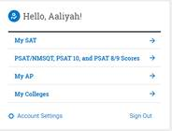

* If you are a student who is planning to attend a postsecondary institution (college, university, etc.), be sure to click on your “AP Profile” and click on the header labeled “**Score Send**.” Enter the name of the college or university you plan to attend so that College Board will send all of your AP scores. This is how the college or university awards you college credit and/or advanced placement at their school.

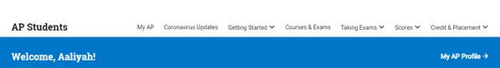

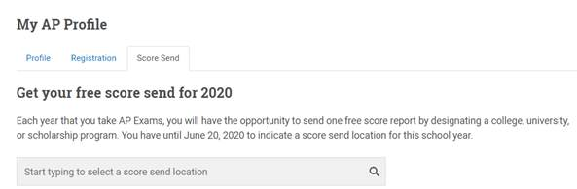

* Please also check to see that your Student ID is listed correctly. This should be your school ID number. To do this, go to “**My AP Profile.”** Click on **“Registration”** and check to be sure your Student ID is listed correctly.

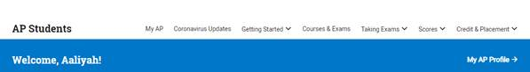

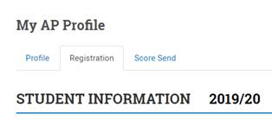

**Testing Accommodations**

Students who have been previously approved for testing accommodations due to an IEP or 504 plan will automatically receive those accommodations from the College Board. Accommodations were applied for and approved or denied in February. If you have questions, please contact your school counselor.

**Canceling AP Exams and Processing Refunds**

Due to COVID-19, there is **no fee for deciding not to take the exam this year.**

*United Way Grant*: Students who have decided **not** to take the AP Exam will have fee assignments **voided**.

*Full-price*: Students who have decided **not** to take the AP Exam will be issued a refund based on the amount they have paid thus far.

* + - 9-11th graders: The refund will show as a surplus.
    - 12th graders: The refund will be issued to the family.
    - *If a 9-11th grader wants a refund issued to the family, they will contact [sharon.fuller@dmschools.org](mailto:sharon.fuller@dmschools.org) who will process the refund (otherwise, the money will remain in the child’s account as surplus for next year).

Amber M. Graeber

AP Coordinator, Des Moines Public Schools

Social Studies Teacher, Roosevelt High School

ap.dmschools.org