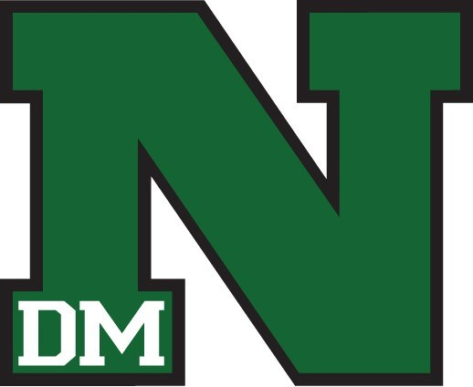
Activities Brochure
Welcome to North High School Activities. Students are encouraged to participate in one of the many activity programs during their four years at North.
At North High School we strive to foster a culture of excellence and prepare our students to succeed in the 21st Century as learners and citizens. We provide activities and athletics for our students because we know that students who are involved have a significantly higher rate of success in school.
We believe that students across the nation are very much the same, but that the levels of expectations that are bestowed upon them vary greatly. At North, we set the bar high and expect and support our students in reaching those high expectations.
Please do not hesitate to contact us with any questions.
Thanks,
Chad Ryan– Activities Director
chad.ryan@dmschools.org 242-7269
Terri Buban– Activities Assistant
teressa.buban@dmschools.org– 242-7204

Fall Sports:

Football: Eric Addy – 515-991-9019
Volleyball: Sabrina Douglass - 515-422-0806
G-Swimming: Scott Weinheimer– 515-321-9816
Boys Golf: Jon Augspurger - 515-707-6989
Girls XC: Charlene Beattie– 515-242-7204
Boys XC: Cory Berkenes – 319-290-5596

Winter Sports:
B-Basketball: Julian Seay – 319-290-5596
G-Basketball: Haywood Boston – 515-447-6558
Wrestling: John Bingham – 515-291-4779
G- Bowling: Alex Bormann - 515-210-3559
B- Bowling: Mike Lucht – 515-205-4849
B- Swimming: Scott Torres - 515-242-7311

Spring Sports:
Girls Track:
Boys Track: Greg Holland– 515-771-3436
Boys Soccer:
Girls Soccer: Lisa Grefe– 515-321-6048
Girls Tennis: Jane Bowen—515-943-7726
Boys Tennis: Gabriel Arroyo – 515-822-9141

Summer Sports:
Baseball: Brandon Weisert - 319-415-9441
Softball: Dominic Ellis - 515-554-7377

Activities:
Band: Bobby Starace
Orchestra: Marisa Maniglia
Drama: Amy Rost
Debate: Jocelynn Klos
Academic Decathlon: Josh Brown
Vocal Music: Vanessa Brady
Polar Bear Senate: Amy Rost
Dance: Abigail Larsen
Cheerleading: Julia Casas
Pep Club: Amy Rost
GSA: Jennifer Dryden
JROTC: 1st Sergent Shaun Leek
Rifle Team: Michael Gettler
Journalism: Jennifer Dryden
Movement 515– Kahara Hunafa
Robotics– Bryan Butcher
Speech– Amy Rost
Sister for Success – Tenelle Thomas
Brother to Brother—Tim Johnson

Important Info:
Website: north.dmschools.org
Phone: 515-242-7204
Twitter: @nhspolarbears
Schedules: cimlcentral.org

